Hockey Canada NCCP Instructional Stream 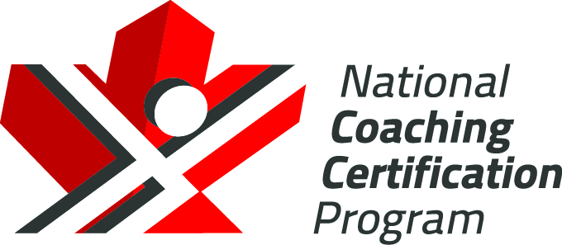
Skating - Level 1 - On – Ice Plan

Drill Name & Description
Skating – Forward Balance and Agility
-Players line up in two lines on the hashmarks
-Both lines can go at the same time, or each line can alternate, skating down the middle to the far end and then back along the boards.
-Perform each skating skill as shown in video

Key Teaching Points

-Technique is important in this warm-up to give the players lots of repetition on technical aspects of skating.

Drill Name & Description
Skating – Backward Balance and Agility
-Players line up in two lines on the hashmarks
-Both lines can go at the same time, or each line can alternate, skating down the middle to the far end and back along the boards.
-Perform each backward skating skill as shown in video

Key Teaching Points

-Technique is important in this warm-up to give the players lots of repetition on technical aspects of skating.

Drill Name & Description
Skating – Speed Progression
-Players line up in two lines on the hashmarks
-Both lines can go at the same time, or each line can alternate, skating down the middle to the far end and back along the boards.
-Perform each backward skating skill as shown in video

Key Teaching Points

-Make sure technique is done correctly before speed. Repeat each skill as many times as necessary until players get the footwork right

Drill Name & Description | 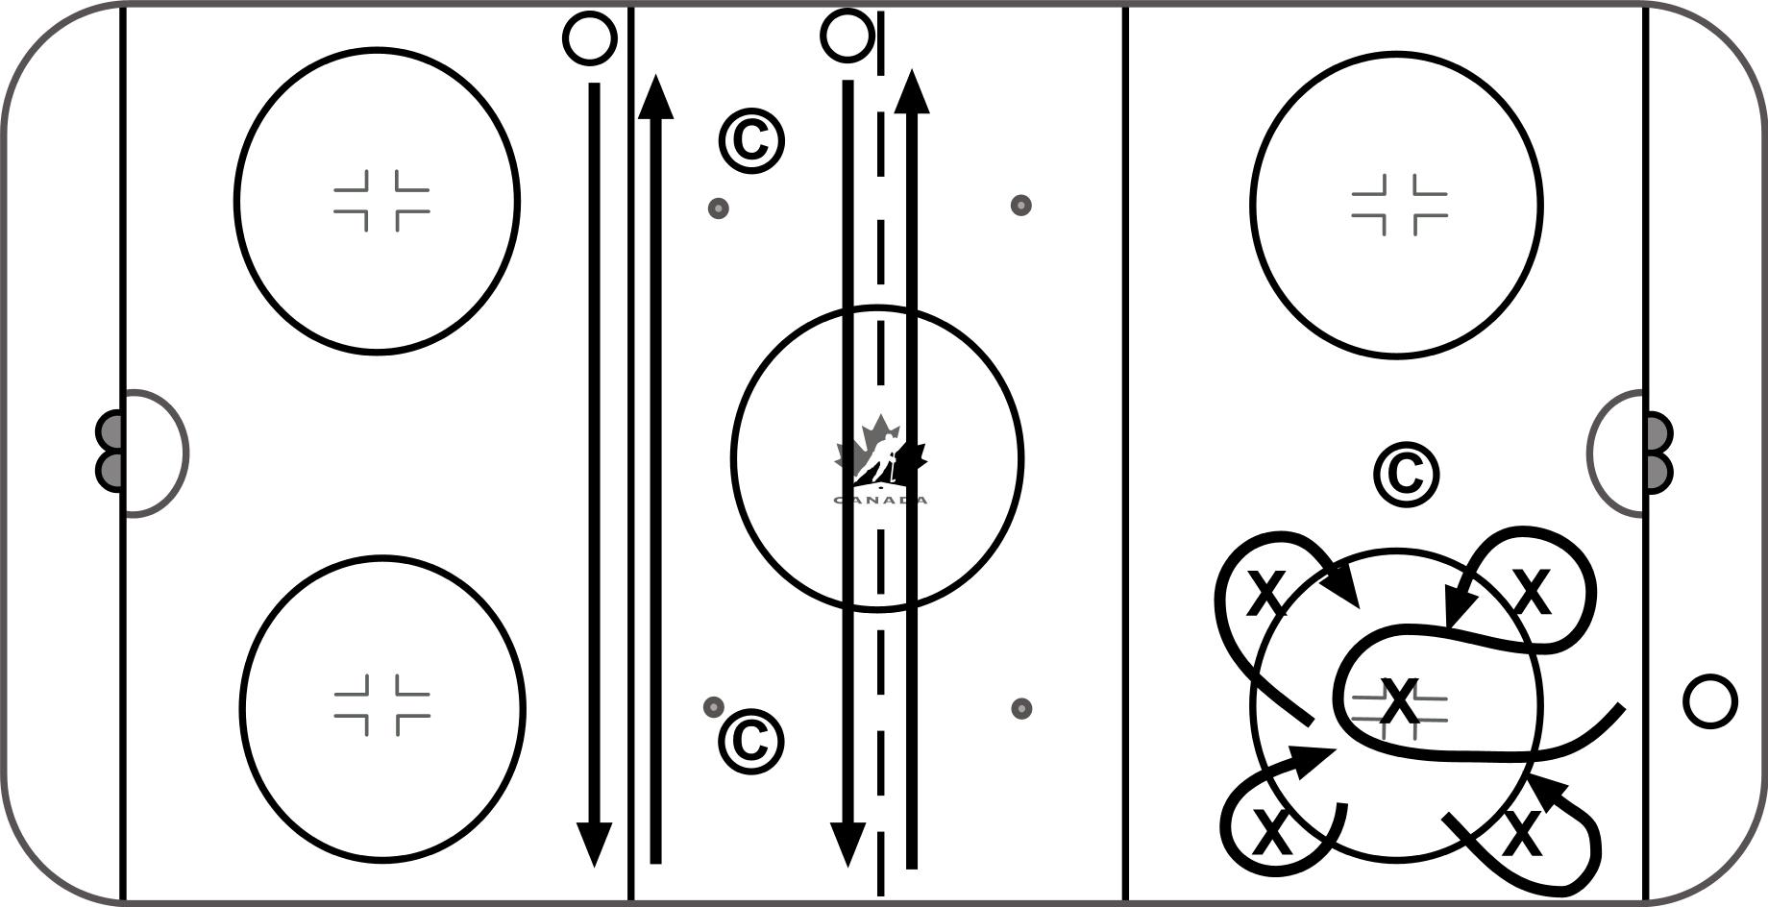
Skating – Inside Edge Control
- Inside Edge Control

Key Teaching Points

-Technique is important in this warm-up to give the players lots of repetition on technical aspects of skating.

- Circle Edge Control

Drill Name & Description
Skating – Forward / Backward Stride
-Players line up in two lines on the hashmarks
-Both lines can go at the same time, or each line can alternate, skating down the middle to the far end and back along the boards.
-Perform each backward skating skill as shown in video

Key Teaching Points

-Technique is important to give the players lots of repetition on technical aspects of skating.

Drill Name & Description | 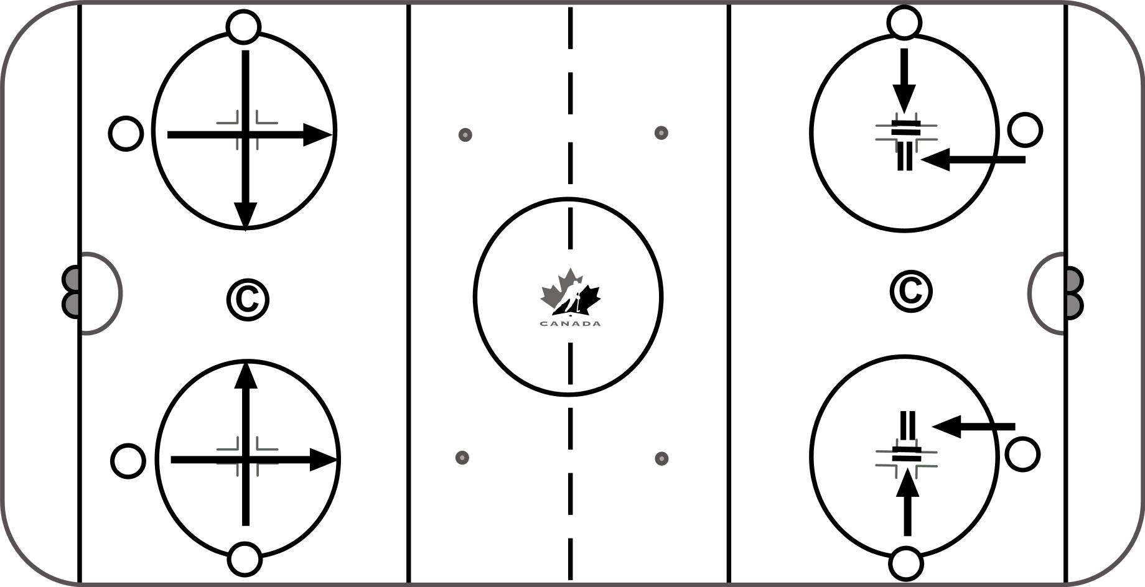
Skating – Starting / Stopping
- Starting
-Players on edge of circle, perform starts across to far side of circle and then stop and come back
-Front Start
-Crossover Start
-Backward Start

Key Teaching Points
-Accelerate out of start / crossover start in both directions / no crossovers on bwd start

- Stopping
-2 Foot Parallel stop
-2 Foot Backward stop
-1 Foot backward stop

Drill Name & Description | 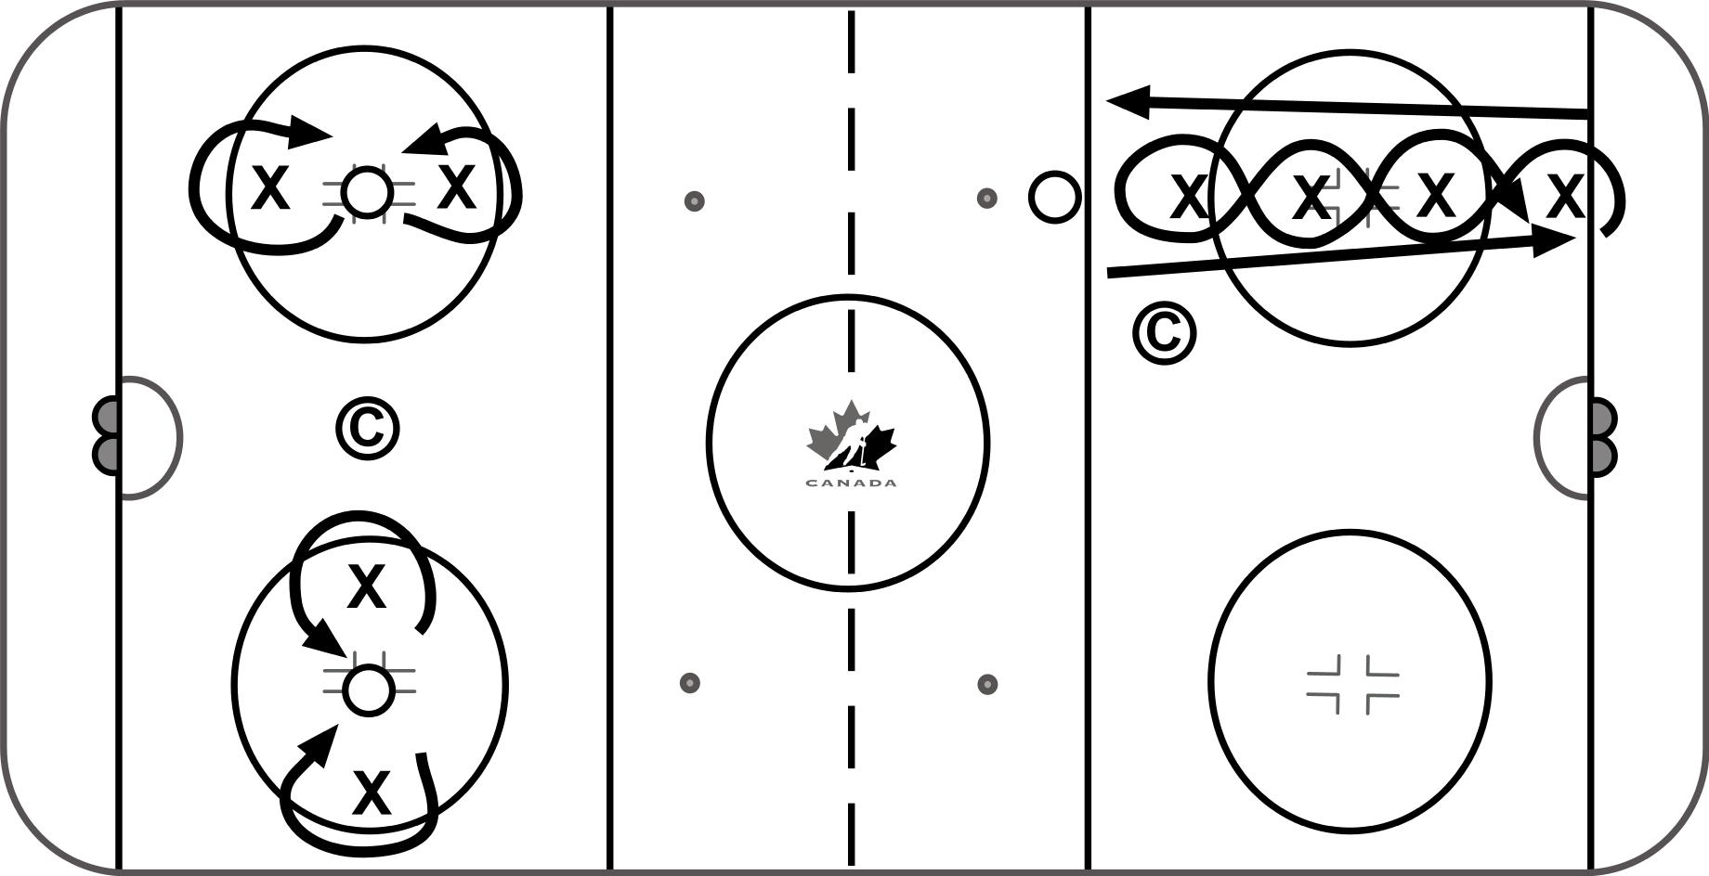
Skating – Turns
- Inside / Outside edge turns
-Place two pylons in the circle about 10 to 12 feet apart.
-Players perform inside edge glide turns around the pylons in a figure-8 pattern / then perform outside edge glide turn
Key Teaching Points
-Good knee bend.
-Follow the stick into the turn.

- Glide Turns
-Place two pylons in the circle about 10 to 12 feet apart.
-Players perform glides on their outside edge of inside skate and inside edge of the outside skate in a figure-8 pattern around the pylons.
Key Teaching Points
-Good knee bend / Stick should be out in front.
-Head should remain level and not move up and down.

- Tight Turns
-Start at the blue line, skate forward towards the far pylon and make a tight turn around first pylon. Weave back through the pylons, making a tight turn around the last pylon (closest to start line), and weave back through the pylons, making a tight turn around the last one. Sprint back to the blue line.
-Each of the pylons are set approximately 10 feet apart.

Drill Name & Description | 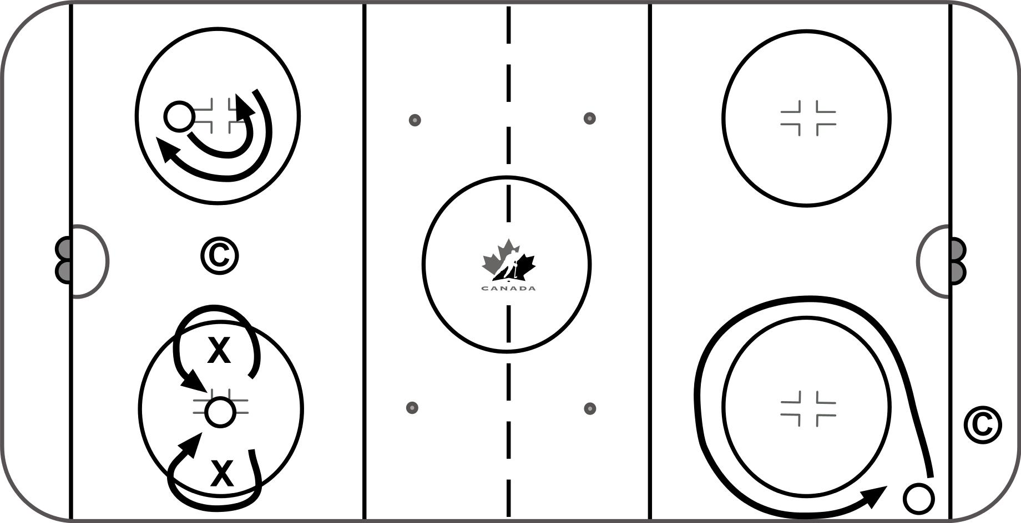
Skating – Heel to Heel Progression
- Heel to Heel – Circle Dot
Players perform heel to heel around the face-off dot
-Repeat in both directions.

Key Teaching Points
-Bend and open knees to get heels to face each other.
-Keep head up.
-Two hands on your stick.

- Heel to Heel – Figure 8
Players line up in the corner.
-Place two pylons in the circle about 10 to 12 feet apart.
-Players perform heel to heels in a figure-8 pattern around the pylons.

Key Teaching Points
-Bend and open knees to get heels to face each other.
-Keep head up.
-Practice both directions.

- Heel to Heel – Full Circle
-Players line up in the corner below the goal line.
-Players leave the corner and perform heel to heels around the circle.
-Repeat in both directions.

Key Teaching Points
-Bend and open knees to get heels to face each other.
-Keep head up.
-Slow, good technique

Drill Name & Description
Skating – Forward Crossovers
-Players line up in the corner below the goal line.
- Players leave the corner and perform crossovers around the circle.
-Repeat in both directions.

Key Teaching Points

-Focus on keeping your shoulders square.
- Perform large crossovers that grab lots of ice and maximize efficiency.
-Slow, good technique.

Drill Name & Description | 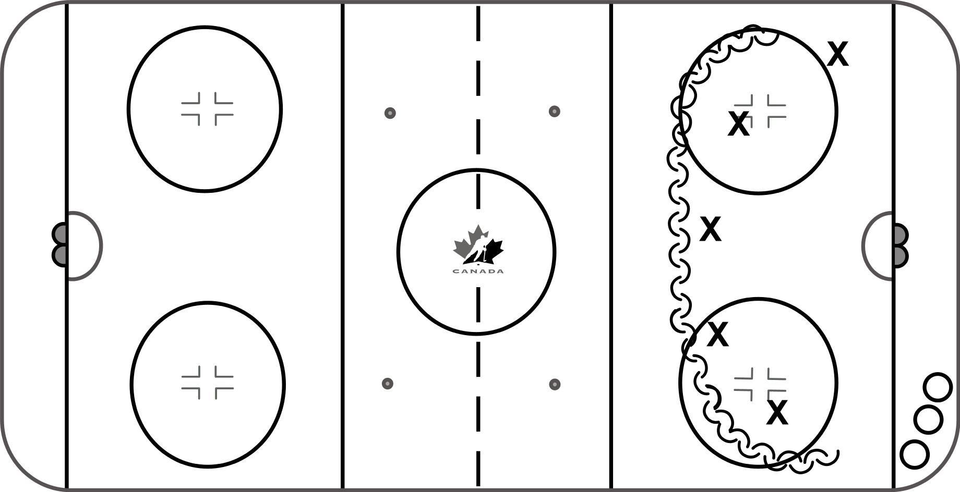
Skating – Backwards Crossovers
-Players line up in the corner below the goal line.
- Use pylons to form a half moon shape along the tops of the circles.
- Players leave the corner and complete bwd crossovers around the pylons.
-Repeat on both sides.

Key Teaching Points

- Heel should turn outward and push into the ice with the recovery occurring close to the glide foot.
-Good knee bend.

Drill Name & Description
Skating – Transition – Heels – Toes First
-Players focus on heels first then toes first transition from forward to backward.
-Players are allowed one crossover after pivot then get into backward stride
-On transition from backward to forward players “ride” and do not cross feet

Key Teaching Points

-Players need to have a good knee bend for balance
-Keep chest and toes up ice
-Limit the crossing of the feet as much as possible
-Players to keep their head up, shoulders back and toes up ice
-Heels and hips first to turn

Drill Name & Description | 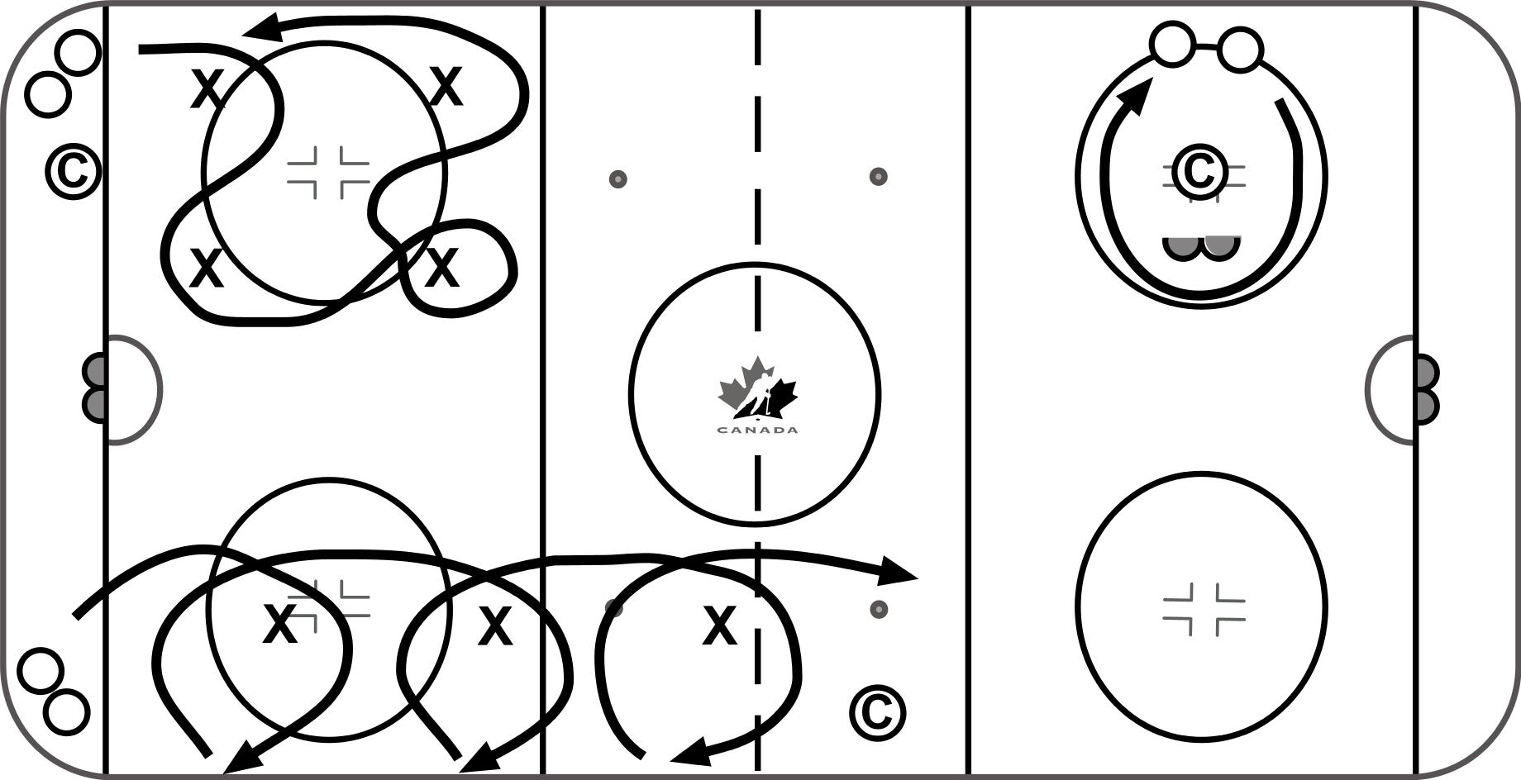
Skating – Change of Direction
- 4 Pylon Agility

-Place 4 pylons around a circle or anywhere on the ice.
-Players start without a puck and skate around the pylons in a random fashion. Add Puck
-Progression – add a second player and have them challenge each other instead of avoiding each other

Key Teaching points
-Keep feet moving, be creative, and go as fast as possible – quick feet

- Agility Nets

-Place a net in the Neutral Zone or anywhere on the ice to use as a station.
-Players perform skating techniques to work on quickness, agility and creativity.

Key Teaching Points
-Turn head before feet to bring body around
-Quick Feet, control the stick

- Quick Feet Crossovers
-Players start in corner
-Skate to first pylon, turn towards boards. Stop at boards, and accelerate out with 2 – 3 quick crossovers to next pylon and repeat
-Repeat with toes facing up ice entire time, grab ice and reach inside to accelerate out turn from backwards to forwards.
-Repeat with pucks.

Key teaching points
-Toes around, accelerate out
-Toes up ice as much as possible

